**­**

Project Kick-off:

Nauti-calamity

Project Pitch

Game & Target Audience

*Nauti-Calamity* is the working title for Project Nautilus, an arcade game that will be launched for the iPhone given one year’s production time in the main studio with a budget of $611,520. *Nauti-Calamity* features Barnacle Bill, the mind-controlling brain barnacle who must survive the dangers of the ocean by attaching himself to sea-life in order to grow bigger and stronger. When attached to an aquatic host, Barnacle Bill controls the movement and feeding of the host, growing stronger as the host feeds. The game features mechanics similar to those found in the arcade games *Fish Frenzy* and *Droid Assault*.

The target audience for *Nauti-Calamity* are tied closely to the target device, the iPhone. As such, college students are one of the primary target demographics for this arcade game, as they are also the primary target demographics for Apple and have more disposable income and a need for entertainment. Research shows that people aged 25 – 34 are most likely to own an iPhone, followed closely by the 18 – 24 age group. The arcade genre ranks in the top 5 iOS game genres in the United States, China, Spain, and Russia, making it a safe genre for a guaranteed audience, but potentially a game with a lot of competition.

Systems & Features

* Account Management
* Achievements
* Leaderboards
* Game Progress Save
* Monetization Plan
* Timed Mode

Images

The following images help to describe the theme and mechanics of *Nauti-Calamity*:

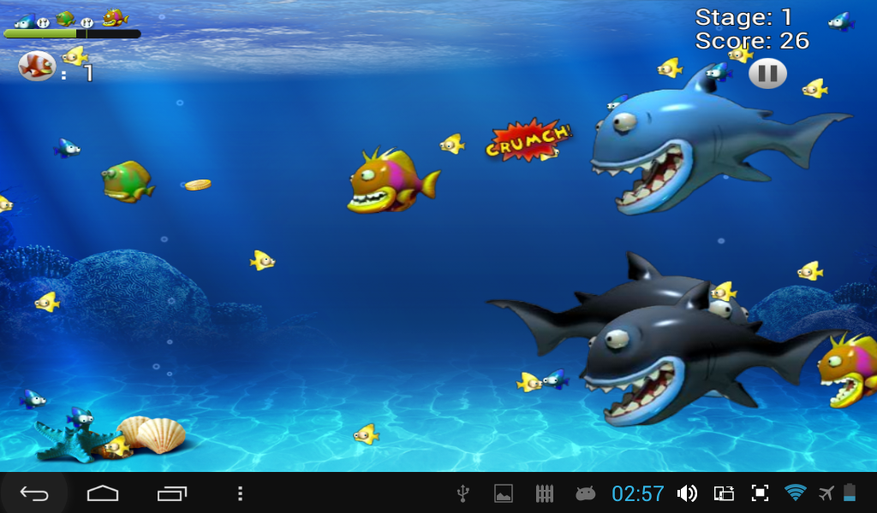

*Feeding Frenzy* shares a similar theme and overall art style.

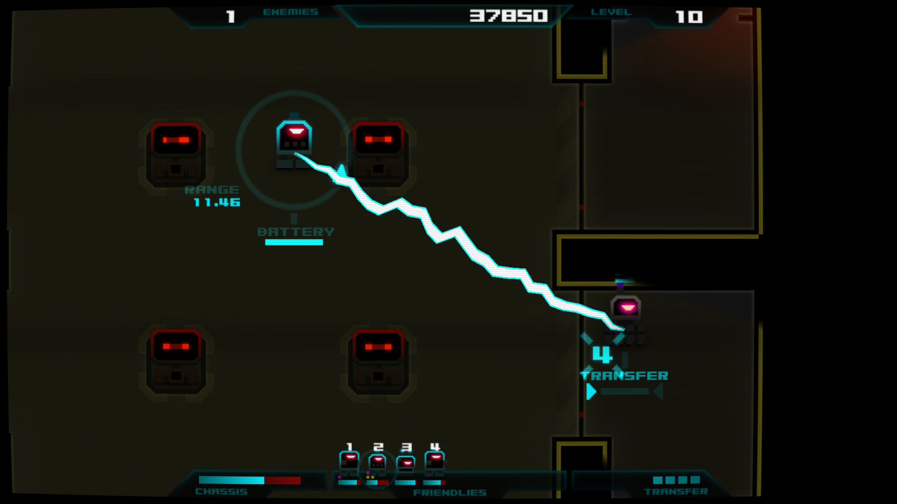

*Droid Assault* shares similar gameplay and mechanics.

Project Plan

Money

Project Nautilus, as it is currently planned, will cost approximately $471,827.93 which is approximately 77% of the budget of $611,520.00. This includes a 20% buffer for additional spending to the currently estimated hiring and technology costs. The additional budget not being spent can be used to offset unforeseen costs during the development cycle. The breakdown for these expenditures are explained in the sections below.

People: Team/Staffing Plan

Project Nautilus has been given the authority to hire 5 – 6 people. The following list of positions to hire is in order of priority with the top most position being the most important:

* Project Manager
  + Seniority of mid-level at $45 per hour
  + Employed for the entire length of the project (52 weeks) = $93,600.00
* General Programmer
  + Seniority of senior-level at $55 per hour.
  + Employed for the entire length of the project (52 weeks) = $114,400.00
* Gameplay & UI/UX Designer
  + Seniority of mid-level at $45 per hour.
  + Employed for the entire length of the project (52 weeks) = $93,600.00
* QA
  + Seniority of junior-level at $35 per hour.
  + Employed for a limited time (40 weeks) = $56,000.00
* 2D Artist
  + Seniority of junior-level at $35 per hour.
  + Employed for a limited time (20 weeks) = $28,000.00

Development Methodology

Project Nautilus will be utilizing the Agile development methodology. The advantages to using an Agile development methodology will allow our team to make changes as they come up through development instead of sticking to a rigid plan. This will allow for additional features, sprint evaluations, product feedback, and also consistent product testing during development to ensure no bugs will exist after the development cycle.

People Total Costs

$385,600.00 + 20% unknowns buffer ($77,120.00) = $462,720.00

Launch Devices

Project Nautilus will be targeting the iPhone, and as such, be focused on developing for iOS. According to research, the 10.X and 9.X versions of iOS has an adoption rate of 87.1% and 8.8%, making up 95.9% of all iPhone operating systems. Due to this, Project Nautilus will need the following dedicated test devices:

* iPhone 7 with iOS 10.X installed
  + $649.00 + $58.41 tax = $707.41
* iPhone 6 with iOS 9.X installed
  + $495.00 + $47.03 tax = $542.03

Software

Project Nautilus will utilize the collaboration and support software available at Reality Games in order to develop our game. In addition, Project Nautilus will need the following engine and support software:

* Engine: Unity 3D
  + 3x Unity Pro Licenses @ $1,500.00 per seat/year + $427.50 tax = $4,927.50 total
  + Unity IAP (In-App-Purchases) – Free
  + Unity Ads – Free
* Adobe Creative Cloud (Photoshop, Illustrator, After Effects, etc.)
  + 2x Creative Cloud Licenses @ $49. per seat/month + $114.00 tax = $1,314.00 total
* Testing Framework: EarlGray iOS Functional UI Testing Framework
  + Open Source – Free
* Apple iOS Store Costs:
  + Yearly fee of $99 with a 30% fee per download/install.

Tech Total Costs:

$7,589.94 + 20% unknowns buffer ($1,517.99) = $9,107.93

Logistics

Project Nautilus will be developed in the main studio. This will allow the team to freely communicate and collaborate on the project with minimal difficulty. There should be no problem setting up meetings or communicating deadlines and no need for remote access for systems and tools. Due to being in the main studio we’ll have to prepare for frequent reports and check-ins on the progress of the project.

Required Systems & Features

The required systems and features are expected to be integrated and useable as created through the production/development cycle and will be completed by the launch/live date.

Assets

The assets needed for the game will include art, sound, music, and scripts needed to make the game. The assets needed for the game will be created during the production/development cycle of the game and will be complete by launch/live date.

Demos/Shows/PR Impact/Dates

Reality Games will be providing the marketing materials and promotion for Project Nautilus and the team will be able to provide pictures/video/content as needed or requested. As the holidays and launch/live date come closer we will have to schedule for additional time needed in order to support demos and shows. Additionally, to get the game approved for the Apple iOS Store it will take an average of 6 days before the game is listed.

Development Plan

Project Nautilus has been allotted a 12-month development cycle with a Holiday 2017 release. This means Pre-production will be given 2 months, Production/Development will be 9 months, and Launch/Live will be given the final 2 months.